Standard Operating Procedure
for Storm water Monitoring using portable samplers

State of Utah
Department of Environmental Quality
Division of Water Quality



Revision 0
Effective April 7, 2020

Utah Division of Water Quality (DWQ) Standard Operating Procedures (SOPs) are adapted from published methods, or developed by in-house technical experts. This document is intended primarily for internal DWQ use. This SOP should not replace any official published methods.

Any reference within this document to specific equipment, manufacturers, or supplies is only for descriptive purposes and does not constitute an endorsement of a particular product or service by the author or by DWQ. Additionally, any distribution of this SOP does not constitute an endorsement of a particular procedure or method.

Although DWQ will follow this SOP in most instances, there may be instances in which DWQ will use an alternative methodology, procedure, or process.

Revision Page

Date | Revision # | Summary of Changes | Sections | Other Comments
4/7/20 | 0 | not applicable | not applicable | New SOP. Began document control/revision tracking.

Table Of Contents

1.0 Scope and Applicability 5
2.0 Summary of Method 6
3.0 Definitions 6
4.0 Health and Safety Warnings 7
5.0 Cautions 8
6.0 Interferences 8
7.0 Personnel Qualifications/Responsibilities 8
8.0 Equipment and Supplies 8
9.0 Procedure 9
10.0 Data and Records Management 21
11.0 Quality Assurance and Quality Control 21
12.0 References 22
13.0 Appendices 23

Scope and Applicability
This document presents the Utah Division of Water Quality’s (DWQ) Standard Operating Procedure (SOP) for the installation, operation, and maintenance of portable samplers in Utah’s natural (rivers, streams, lakes) or engineered (storm water outfalls, ditches, canals, reservoirs) surface water bodies. It is anticipated that the primary use of portable samplers for storm water monitoring will be to obtain water quality data from storm water outfalls during and following precipitation events. This SOP applies to DWQ staff or cooperator installing or maintaining portable samplers for storm water monitoring. This SOP also outlines the responsibilities of DWQ staff to perform inspections of portable samplers and associated equipment while collecting water samples.
Portable samplers are an effective and efficient means to collect water quality samples for laboratory analysis of chemical parameters such as nutrients, metals, and total dissolved solids. When combined with an area velocity flow meter or other flow measurement device, portable samplers can be used to quantify pollutant loads at remote locations that flow intermittently from precipitation driven events.
Portable samplers consist of a peristaltic pump connected to a tube and strainer that is placed in the flow path of the water body to be sampled and transfers water samples to one or more bottles housed within the portable sampler’s body. The pump is powered by a control unit that when combined with a flow meter can be programmed to initiate sampling based on flow as well as control the timing and duration of sampling to obtain a flow-weighted composite sample. Composite sample data is used by DWQ scientists and engineers for a variety of purposes including but not limited to:
- determining pollutant loading and inputs into receiving waterbodies
- setting permit requirements for discharge of storm water
- characterizing current water quality conditions and detecting long-term changes
Portable sampler controllers can also log flow rate, rainfall, and parameter data when combined with a flow meter, rain gauge, and sonde. When connected to a wireless modem the controller can provide system status updates and alert the user when samples have been collected through email or text messages. Power to operate the pump and controller is provided by a standard 12 volt DC lead acid or equivalent battery.
The information discussed in this SOP is not a substitute for equipment user manuals or other technical documentation. Consult the appropriate manual for a complete guide to the proper use, calibration, maintenance, deployment, and troubleshooting of portable sampler equipment and software. This SOP is to be used as a reference but the complete user manual should always accompany the field personnel.

Summary of Method
The portable samplers will be programmed to collect samples from precipitation events that are expected to total at least 0.1 inches in depth and occur at least 72 hours from the previous qualifying storm event. If the precipitation event does not result in at least 0.1 inches in depth the sample will be discarded and not composited for analysis. A flow-weighted composite sample of each storm event from each location will be analyzed to obtain the Event Mean Concentration (EMC) of the constituents of interest (COI) for that event.
Flow-weighted, whole water (unfiltered) sample aliquots will be collected over the course of the storm event with portable samplers. These whole water samples will be retrieved from the field by the sampling team and transported to the DEQ Tech Support Center. Samples will be removed from the portable sampler using two-person clean sampling techniques similar in concept to the “clean hands – dirty hands” method (EPA 1996).
Portable sampler performance will be evaluated and water from the individual sample bottles will be composited into a single container. Following sample compositing, sample bottles for individual COIs will be filled using a peristaltic pump.
Once the composite samples for analysis are collected and preserved (if applicable), the sample containers will be capped, labeled, and placed on ice or refrigerated at the TSC until transported to the laboratory. Each refrigeration unit at the TSC will be monitored bi-weekly to ensure temperature compliance. Each unit will have a separate log form containing date, time and temperature information. Samples will be handled following the procedures described in the Chain of Custody SOP (https://documents.deq.utah.gov/water-quality/monitoring-reporting/SOP/DWQ-2019-001920.pdf).
The installation site of the portable sampler will be assessed for feasible placement of the sampling tube inside of a storm water outfall or structure, with the bottom of the tube as close as possible to the low water level of the storm water discharge. The elevation difference between the sample tube and the bottles shall not exceed 20 feet due to the limitation of how much head pressure the pump can generate to transfer water to the sample bottle. The flow meter will be installed on the top of the storm water pipe or structure facing downwards onto the flow path and tubing and cabling secured to prevent debris from snagging on it. The portable sampler and battery will be housed in a secured enclosure at the site to safeguard against theft and vandalism.

Definitions
Area Velocity Flow Meter: A device that measures water flow.
Portable Sampler: A unit that can be programmed to collect discrete sequential samples, time-composite samples or flow-composite samples.
Base flow: Flows occurring in the drainage after 48 hours with no measurable rainfall are defined as base flows. This flow may be consistent or intermittent within a storm water conveyance system.
Best Management Practice (BMP): Physical, structural, and/or managerial practices that, when used singly or in combination, reduce the downstream quality and quantity impacts of storm water.
Composite Sample: Used to determine “average” loadings or concentrations of pollutants, such samples are collected at specified intervals based on time, flow volume or flow rate, and are pooled into one large sample.
Conveyance System: A single pipe or series of pipes that convey storm water as part of a municipal separate storm sewer drainage system.
Drainage area: The area contributing runoff to a single point measured in a horizontal plane, which is enclosed by a ridge line.
Event Mean Concentration (EMC): The average pollutant concentration for a given stormwater event, expressed in units of mass per volume (e.g., mg/L). The EMC accurately depicts pollutant levels from a site and is most representative of average pollutant concentrations over an entire runoff event.
Hydrograph: A graph of runoff rate, inflow rate or discharge rate past a specific point as a function of time.
Outfall: Location where an effluent or municipal separate storm sewer system discharges into receiving waters.
Pollutant Load: A mass concentration multiplied by the total volume of water passing by a certain point in time.
Storm Water: That portion of precipitation that does not naturally percolate into the ground or evaporate, but flows via overland flow, interflow, channels, or pipes into a defined surface water channel or a constructed infiltration facility. According to 40 CFR, part 122.26(b)(13), this includes storm water runoff, snow melt runoff and surface runoff and drainage.
Time of Concentration: The time of travel for rain runoff from the farthest point in the tributary area to the sampling location.

Health and Safety Warnings
In most cases, installation of portable samplers will take place at or near storm water outfalls and near stream or lake shorelines that may be stabilized with rip-rap, which can be unstable, slippery, and sharp. Power tools, including hammer drills and reciprocating saws, can be hazardous if used improperly. Working near water in waders poses a drowning hazard, and working near water in the winter poses a hypothermia hazard.

Cautions
The placement of portable samplers in the field should be considered carefully due to the potential for vandalism and theft of sampling equipment. A nondescript enclosure secured to a heavy base and locked access door is recommended to discourage tampering and prevent theft.

Interferences
A strainer must always be attached to the intake end of the sample tube installed within the water source being sampled to prevent clogging. The sample tube and area velocity flow meter must be anchored firmly to prevent movement and snagging on debris.

Personnel Qualifications/Responsibilities
DWQ monitoring staff will be responsible for installation and maintenance of portable samplers. This monitor will also be responsible for training new field staff.
Personnel installing portable samplers should be knowledgeable of the relation between storm events, timing of runoff, and outfall discharge volume. Programming the control unit requires knowledge of computers and deployment software. Installation of the portable sampler housing, sample tube, flow sensor and transducers is physically demanding and requires the use of a 3 pound hammer, hammer drill, and cable cutters.
Personnel that may be performing inspections of installed portable samplers are required to read this SOP annually and acknowledge they have done so via a signature page (see Appendix A) that will be kept on-file at DWQ along with the official hard copy of this SOP. Before new personnel can install portable samplers or perform maintenance they must be trained by an experienced DWQ monitor. The signature page will be signed by both trainee and trainer to confirm that training was successfully completed and that the new monitor is competent in carrying out this SOP.

Equipment and Supplies
- Copy of this SOP
- Field Form (Appendix B)
- Isco® Model 3700 portable sampler or equivalent. Includes controller, top cover, center section, base, and distributor arm.
- Signature® Area Velocity flow meter system (AVFM) or equivalent.
- Flowlink Pro software
- AVFM Sensor carrier and mounting plate.
- 306 sampler interface assembly with 10 m long cable
- CDMA LTE cellular modem with magnetic mount antenna.
- Connect cable for external 12 VDC source, typically a deep cycle marine battery.
- Deep cycle 12V DC marine battery, 50 amp hour minimum
- 3/8 inch vinyl suction line – 100 feet
- 3/8 inch stainless steel tubing coupler
- 3/8 inch stainless steel strainer
- 24 polypropylene 1-liter bottles with caps, bottle retaining ring, and two pump tubes
- Laptop or desktop computer to communicate with the Isco 3700 controller.
- Attachment materials and tools
  - ¾-inch SS strapping, seals, and tensioner
  - Hammer drill, 3/32-inch masonry bits, ¼-inch X 2-inch masonry screws
  - Powder-actuated nailer, powder charges, and concrete pins
  - 1.5-inch two-hole metal conduit straps
  - Tin snips
- Keyed or combination long-shackle padlock to secure the enclosure containing the portable sampler (Utah DWQ uses combination locks; combination code can be found in the site portfolio)
- Box of nitrile gloves
- Cooler

Procedure
  - Equipment Decontamination
Equipment decontamination procedures are described below to be conducted at the end of the monitoring season when the units are retrieved from the field.
Sample Tube
- Rinse twice with reagent grade acetone
- Rinse thoroughly with hot tap water using a brush to remove particulate matter and surface film
- Rinse thoroughly three times with tap water
- Rinse with 20% hydrochloric acid (HCl)
- Rinse thoroughly three times with tap water
- Rinse thoroughly three times with DI water
- Rinse thoroughly with petroleum ether and dry by pulling air through the line
- If possible dry overnight in a warm oven of lower than 150ºF
- Cap ends with aluminum foil
Pump Tube
- Pump hot water through the tube for at least 2 minutes
- Rinse tube with 20% hydrochloric acid (HCl) for at least 2 minutes
- Rinse by pumping hot tap water through the tube for at least 2 minutes
- Rinse by pumping DI water through the tube for at least 2 minutes
Sampler
The sampler top cover, center section, retaining ring, and tub of the portable sampler will be cleaned with warm soapy water and rinsed with tap water. The two pump drain holes will be checked to see that they are open and free of debris or buildup.
During implementation of the field sampling protocol, it is not anticipated that screens and intake tubes will be removed for cleaning between sampling events. The sampler will be programmed to purge the intake tubes several times before and after each storm water sample collected, which should ensure that any contamination from previous events is removed or sufficiently diluted to be unimportant. If upon routine inspection, it is observed that algae is growing in the intake tube, debris is blocking the tube, or any other contamination issues exist, contaminated screens and intake tubes will be replaced with screens and intake tubes decontaminated using the methods described above.
Sampler Mounts and Other Equipment
Mounting equipment such as slip rings, nuts, bolts, and brackets will be washed with warm soapy water using a brush to remove any oil, grease or other residue from the manufacturing process. They will then be rinsed with reagent grade acetone followed by DI water and allowed to dry.
Installation of the brackets at the sampling sites may create debris that could become a contaminant source (i.e. drilling holes, using powder-actuated tools to set studs and/or welds). After the brackets have been installed, the work site will be scrubbed with a brush to remove any debris and rinsed with DI water before the sampling hardware (intake screen) is mounted.
Coolers used to transport samples will be washed with warm soapy water using a brush to remove any residue and rinsed with tap water.
Sample Containers
Sample containers will be certified pre-cleaned containers obtained through the laboratory.
Storm Water Sample Collection
The clean handling techniques are modeled after the “clean hands – dirty hands” (EPA 1996) method for collecting samples. The clean/dirty hands technique requires two or more people working together. At the field site, one person is designated as “clean hands” (CH) and a second person as “dirty hands” (DH). Although specific tasks are assigned at the start some tasks overlap and can be handled by either as long as contamination is not introduced into the samples. Both people wear appropriate non-contaminating, disposable, powderless gloves during the entire sampling operation and change gloves frequently with each change in task.
CH takes care of all operations that involve equipment that comes into contact with the sample:
Handles the storm water collection vessels (removes and replaces from the sampler)
Handles collection vessels until they are placed and sealed into coolers
Prepares a clean workspace in DEQ Tech Support Center
DH takes care of all operations that involve contact with potential sources of contamination and is responsible for the following:
Works exclusively exterior to the samplers
Removes sampler from the catch basins, if necessary, and releases catches and lifts off sampler cover for CH
Replaces cover and latches sampler cover
Handles the tools, such as hammers, wrenches, keys and locks
Handles sondes for field measurements
Sets up and calibrates field measurement instruments
Measures and records field measurements
Seals coolers
Storm Water Sampling Procedures
Two people are needed to conduct the sampling including sample logging, processing, lifting the sampler in and out of the housing or catch basin, and recording storm water parameters. When collecting the water samples from the samplers, DH will remove the manhole or housing lid and CH will clear a work space and lay down a plastic sheet. DH will place the sampler on the plastic sheet, release the catches on the sampler, and lift away the cover and place it on the plastic sheet. CH will then install caps on each of the collection vessels, label it with a waterproof label, and place it in the cooler.
After the collection vessels have been removed from the sampler CH installs new “Certified Clean” collection vessels in the sampler. DH replaces the cover and latches it. DH will place the sampler back in the catch basin or housing and close and lock the lid if applicable.
Sample Processing
Samples from the sampler collection vessels are stored in sealed coolers with wet ice and transferred to the DEQ Tech Support Center at the conclusion of the sampling event. The field leader is responsible for maintaining sample integrity throughout the event. Once at the DEQ Tech Support Center, sample contamination is avoided by handling the collection vessels with clean non-contaminating gloves and transferring the collection vessels into clean refrigerators immediately after they are brought back from the field.
Sample Compositing
As part of the field sampling procedures, the sampling team will download the sampling report and flow data from the data logger and review the data upon arrival at the DEQ Tech Support Center. If the sampling report and flow data indicate that there was no malfunction and all the sample bottles are intact, the sample compositing and preparation will continue as follows.
If the sampler contains multiple bottles, the contents of each will be emptied into a large mixing container, decontaminated in the same manner as the collection vessels and composited (i.e. using a churn splitter or other suitable apparatus). If instead the sampler contains a large volume composite bottle, the entire contents of this bottle will be emptied into the same mixing container. Following sample compositing in the mixing container, composited water will be transferred to analytical sample bottles, with preservative if applicable, using a peristaltic pump (the pump tube will be decontaminated in the same manner as described previously for the sample tube). The analytical sample bottles will be capped, labeled, and placed inside a cooler for transport to the analytical laboratory.
Whole water samples for general chemistry and unfiltered/filtered water pairs for metals and nutrients will be prepared by the sampling teams from the composite sample. Each sample will be analyzed for the chemicals shown in Table 1. Filtered metals and nutrient samples will be prepared by pumping composite water by means of a peristaltic pump through a 0.45 micron filter, dispensing directly into analytical sample bottles dedicated for filtered metals and filtered nutrient sample bottles. Decontaminated equipment for sample compositing and processing (i.e. mixing containers, pump tubing, and filters) will be used for samples collected from each location to prevent cross contamination between samples.
Table 1. Portable Sampler Chemical Parameters for Analysis in Order of Priority
Description | Details | Parameters
Total Metals | One 250 mL Total Metals plastic bottle with HNO₃ preservative to pH <2 | Arsenic  Cadmium  Copper  Lead  Mercury  Selenium  Zinc
Dissolved Metals | One 250 mL Filtered Metals plastic bottle with HNO₃ preservative to pH <2 | Arsenic  Cadmium  Copper  Lead  Mercury  Selenium  Zinc
Total Nutrients | One 500 mL Nutrient Analysis plastic bottle with H₂SO₄ preservative to pH<2 | Ammonia  Nitrate/Nitrite  Total Phosphorus  Total Nitrogen
Dissolved Nutrients | One 250 mL Filtered Nutrients plastic bottle with H₂SO₄ preservative to pH<2 | Ammonia  Nitrate/Nitrite  Total Phosphorus  Total Nitrogen
General Chemistry | One 1000 mL unpreserved plastic bottle | Total suspended solids  Volatile suspended solids  Total dissolved solids
Contingencies
Several problems could occur that may affect the viability of a sample collected. Common potential problems and contingencies are as follows:
- Sample volume is not adequate for all analyses. This may occur when the forecasted precipitation is substantially greater than the actual site precipitation. Under these sampling conditions, the sample will be composited as normal and samples for analyses will prepared in the priority order shown in Table 1.
- Sample exceeds sampler collection vessel capacity. The sampler report will indicate that the bottle capacity was exceeded. This may occur when the forecasted precipitation is substantially less than the actual site precipitation. In this case the flow data will be evaluated; if the collected samples represent 50 percent or greater of the total storm and encompass some of the falling limb of the storm, the total volume will be composited and analyzed per normal procedure. If the sample volume represents less than 50 percent of the total storm volume, it should be composited and held at the DEQ Tech Support Center for possible analysis at a later date in the event that no further storm events can be successfully captured.
- A portion of the sample is lost. This would occur when one or more of the sampler collection vessels are damaged or if the sampler malfunctions. In this situation, the sampling report and flow data will be reviewed to determine what representative portion of the storm volume is missing. In this situation it may be possible that a significant portion of the storm was not sampled, and/or there is not adequate volume to complete the desired analyses. Following the process of the two previous scenarios, if the collected sample volume represents 50 percent of the storm and both rising and falling limb conditions are included, then the sample will be used. If not, it will be archived at the DEQ Tech Support Center as described above. If the sample meets the above conditions but the volume is inadequate to conduct all analyses, the sample containers will be filled in the priority order of analyses shown in Table 1.
Field Quality Control Procedures
The sampling program is designed to collect additional volume for field and laboratory QC samples at the following frequencies:
Field duplicates – 1 per 20 samples
Equipment blank for all analyte groups – 1 per 2 samples
The types of field QC sample collection are described below (USGS 2000).
Field duplicate: A field duplicate sample consists of aliquots of the same composited sample that are equally distributed in two sets of sample containers. These samples will be analyzed identically to evaluate the repeatability of sample handling, analytical procedures, and sample heterogeneity.
Equipment blank: Equipment blanks are used to determine if any contaminants or interferences are introduced as part of the sampling equipment or the processes of cleaning that equipment prior to sampling. Deionized water is passed through the sampling equipment and collected in sampling bottles. These samples are sent to the laboratory for analyses. Corrective action is taken if any contamination is found in these blank samples.
  - Installation
    - Monitoring Site Selection
Select a representative site to ensure data is collected which best represents the storm runoff condition through the storm water conveyance. The following consideration must be included in selecting a representative site:
A representative sampling location should include a storm water outfall located where storm water is relatively well mixed and relatively “stable” or “uniform”.
For selecting sites with uniform flows, avoid steep slopes, junctions, confluences, grade changes, and areas of irregular channel shape due to breaks, repairs, roots, debris, etc. Sites with pipe slopes less than 2% typically have uniform flows.
Select sites where the channel and storm drains are soundly constructed and have free-flowing (gravity flow) conditions. Avoid selecting sites affected by backwater conditions since these areas can complicate measurement of flow and the interpretation of data.
Ensure the influent sampling station will not include any prior treatment of storm water up gradient from the station.
Obtain permission for site access and conduct a follow-up site inspection during dry and wet weather.
Note the following information for each selected monitoring site in field notebooks: The contributing drainage area flowing to the site; The discharge tributary system (discharge to receiving water or other area); and, Site constraints or safety concerns.
During dry weather, inspect the site for base flows (dry weather flows, presence of debris, signs of staining, odors, discoloration in water, unusual flows and/or excessive sediment/solids deposits. Note observations in field notebooks. During wet weather, inspect the discharge flow condition to get a sense of sampling conditions during storm runoff events. Note observations in field notebooks.
    - Equipment Installation
For installation of the sample tube, meter probes and triggering equipment, locate the appropriate place at the monitoring station for representative placement. The selected area should be an area where the runoff stream is adequately well mixed to ensure representative sampling from the entire cross-section of the conveyance system (typically mid-stream in the pipe/channel). The sample tube, other parameter probes and sampler triggering devices must be placed downstream of flow monitoring devices in such a matter as to not create turbulence which can influence flow measurements.
- Prior to installation and equipment handling, wear clean, powder-free gloves and practice clean handling techniques.
- Cover the end of the sample tubing with new aluminum foil, tape or laboratory-grade cellophane to prevent contamination during installation.
- If confined space entry is required to install the sample tube, ensure field staff is properly trained and certified.
- Place the sample tubing in the storm water conveyance system where it will best represent runoff through the system providing at least 2” of depth or greater for the tube. The sample tube must be covered during sampling to avoid improper aliquot collection.
- For placement of the sample tube in less than 2 inches of water, a depth can be created by constructing a deeper pool, for example with weirs or flumes.
- Take caution when placing any constriction in the pipe since it can also cause sedimentation which can cover the tube’s intake end and affect the aliquot volume collected.
- If constricting items are used, provide regular maintenance and checks to keep the sampler intake free of debris and sedimentation.
- If necessary, mount the sample tube slightly above mid-stream on one side of the pipe/channel if high solids loadings (bed load, trash, debris) are present. However, with the sample tube offset of the mid-channel, low flows may not completely submerge the strainer.
- Place the sample tubing mid-stream, facing upstream, parallel to the water flow and downstream of the flow measuring device. The line should not be placed in an eddy or area of flow disturbance.
- Place the line to avoid disturbance or turbulence in the flow pattern (this could interfere with flow measurements).
- Prevent clogging by adjusting the tubing at an angle.
- Use an anchor system or anchors to secure the tubing. Some manufacturers have a mounting plate available to mount the tubing and other probes in the channel or pipe.
- Anchor the line to prevent bending/crimping during high velocity storm flows within the pipe/channel. Place an anchor every 20 inches for higher-velocity flows.
- Ensure there are not kinks or dips in the tubing which can hold residual amounts of liquid or deposited storm water solids/sediments that could cross-contaminate sample volumes.
- Attach a strainer to the end of the pre-cleaned sample tubing. Slide the end of the strainer into the tubing and secure it with a stainless steel hose clamp.
- Cut the tubing to the desired length in 1 foot increments and cap the end with new aluminum foil, tape or laboratory-grade cellophane to prevent contamination.
- The minimum length of the pump tubing must be used to minimize the contact of the sample water and tubing as the sample water is carried from the intake tubing into the sample containers. See the manufacturer documentation on the technical limits for the portable sampler pump and the recommended maximum length of tubing, and for limitations in elevation difference between pickup point and sampler.
- If the sampling program is long-term, the sample tubing can remain in-place for extended periods, however, provisions must be made for flushing the tubing thoroughly with de-ionized water before each sampling event and with site water (de-ionized or ambient water) before each aliquot is drawn. It is recommended to replace the tubing periodically, semiannually or annually, depending on site conditions. The frequency of replacement and methods used for cleaning of the tubing should be recorded with collection of quality assurance/quality control (QA/QC) samples.
- Measure the entire length of tubing since this information is needed when programming the portable sampler. Record measurements in field notebooks.
- Install all other appropriate probes and sampler triggering devices such as the velocity flow meter near the sample tube.
- All equipment installed within storm water conveyance systems should be secured in a way to not create turbulence and not to dislodge from the sampling location. Turbulence can create cavitation (air pockets) around the sample tube which varies the volume of water sampled for each aliquot.
- For the installation of the portable sampler, place the sampler on a level surface as close to the sample intake as possible. See the manufacturer documentation on the technical limits for the portable sampler pump including vertical pump height and the recommended maximum length of tubing. It is recommended that the vertical distance be a maximum between 26-28 feet depending on equipment used. The sampler should never be placed at a height below the sampler intake. This situation would create a siphon.
- When sampling for metals, only stainless steel fittings or clamps should be used in all areas of sample contact. Other metallic hardware (plates, fittings, conduit, and clamps) should not be used in areas of sample contact. Take care to ensure that the ends of all tubing do not touch any object that is not known to be clean during installation. Metallic hardware can be used only in areas where contact with the sample doesn’t occur e.g., anchors used on the outside of the tubing.
- For above-ground enclosures, install housing/enclosure for the equipment well above the highest water level expected.
- Secure enclosure in such a manner to prevent tipping, vandalism, or theft.
- Use an electrical metal conduit, plastic conduit or a water pipe to protect the length of sample intake tubing from sampling point into the enclosure. Make sure the conduit is large enough to accommodate all connection cables (flow meter, parameter probes, and rain gauge), and that any rough or sharp edges resulting from cutting the conduit are removed by reaming or scraping.
- Place the sampler on a level surface within the enclosure and lock to prevent equipment theft/vandalism.
- For placement within a manhole or junction box, place the portable sampler either on a shelf in the manhole/catch basin junction box or hang sampler inside the manhole/catch basin. Some manufactures have suspension harnesses and other anchors commercially available.
- Make sure that the sampler is above any high water level within the pipe. High water, such as surcharging or tidal water, can float the sampler damaging the sampler unit and/or its electronics and can contaminate the enclosed sample container(s) once the sampler is submerged.
- Secure the sampler in place.
- Install a secondary “safety line” for all equipment to prevent equipment from being lost if the platform or hanger fails.
    - Preparing the Sampler
  - Remove the cover or top of the sampler and carefully place it to the side making sure not to kink the sample intake line.
  - Prepare the base section for the desired configuration (composite bottle or sequential multi-bottle setup).
  - Place the cover back on and feed the pre-cleaned flexible pump tubing through the peristaltic pump and into the area of the sampler where the sample bottle(s) are housed.
  - Take care to ensure that the ends of the tubing do not touch any object that is not known to be clean during installation.
  - Slide the end of the sample intake tubing (at least ½ inch) into the pump tubing and secure it with a hose clamp, if necessary.
  - Connect other equipment to sampler such as flow meters, rain gauges, level actuator, and/or parameter probes.
  - Attach the power source to sampler (solar, AC, battery).
  - Turn on the sampler and any other equipment.
  - To check the sampler function, purge the sample tubing with site water or de-ionized water to make sure the sampler is operating properly. See manufacturer’s manual.
    - Sampler Programming
Portable samplers alone or with flow measurement devices can be programmed to collect various types of samples including time composite, flow composite, and sequential (multi-bottle) sampling schemes. Each type of equipment system has unique programming elements; however, these three elements are common to all systems: flow quantity interval, the total number of aliquot samples and the volume of each aliquot sample.
In general, the portable sampler is programmed to collect a sample aliquot each time it receives a pulse. The pulse can be either time-based or flow-based.
For specific, step-by-step procedures for programming the portable sampler, refer to the Manufacturer’s User Manual.
Programs can vary between portable equipment but some elements are similar and include: start sampling (enable) and end sampling (disable) options. These options are dependent upon flow depth, flow velocity, precipitation amount, or time.
To ensure the collection of representative samples, portable samplers should be programmed to perform a back-flow purge cycle in between each aliquot collected. Purging the sample intake tube prior to collection of each aliquot also helps keep the line clear.
  - Inspection and Maintenance
The success of any sampling program is dependent on the proper maintenance of the equipment. Maintenance of the portable sampler and other complementary equipment is required especially when the equipment is in place for extended periods of time or when sampling multiple events.
Because of the adverse operating conditions associated with sampling (exposure to extreme conditions and events), the equipment should be maintained frequently and after each sampling event.
Perform regular maintenance every time the sampler is set to collect a storm event. Regular maintenance includes, but is not limited to:
  - Check to make sure all connections are tight.
  - Inspect the strainer and clear it of debris and sedimentation if necessary.
  - Make sure tubing is secure.
  - Inspect sample intake tubing for kinks, cracks, biological buildup, and unusual discoloration and replace if necessary.
  - If the site to be monitored for an extended period, it is recommended to replace the tubing on an annual basis. Other replacement schedules may be required, depending on the specific installation and project requirements.
  - Inspect pump tubing for wear, cracks, biological buildup, and unusual discoloration. Replace with de-contaminated pump tubing periodically.
  - Note maintenance activities in a field notebook
  - Calibrate the portable sampler every time the sampler is set to collect a storm event. Use procedures in accordance with manufacturer specifications.
  - Rinse tubing with de-ionized water, or site water (i.e., storm water or ambient water such as base flow).
  - Check the sampler by collecting a manual sample at the desired setting using the sampler and measure its volume.
  - Check the sample bottle(s) to verify the desired sample volume was delivered to the sample bottle(s). If not, recalibrate the desired sample volume.
  - Adjust the sample volume to the desired sample aliquot volume according to manufacturer specifications.
  - Note calibration in a field notebook.

Data and Records Management
Specific data and records management requirements can be found in the project specifc SAP. Sample bottles must be labeled properly and the information on the label must match the information on the “Lab Sheet” or other sample tracking or Chain-of-Custody form. Information on sample labels must be written in permanent ink, preferably using a “Sharpie” brand marker. For samples to be analyzed at the State Lab, sample labels must contain the following information: Site code/ID, site description, date, time, and sampler(s). Before leaving field site, be sure that all required samples have been collected, labeled, and that all appropriate field sheets, field notes, and sample tracking forms have been filled out completely and accurately. DWQ must receive a photocopy or scanned electronic copy of each “Lab Sheet”, sample tracking form, or Chain-of-Custody form. These forms are given to the DWQ’s Database Manager and used to perform data verification and track expected analytical results from the laboratory. The copies are then stored in the appropriate project file.
- The field form in Appendix B should be included in the site portfolio of every site where a portable sampler has been installed. Use this form to record the installation of the portable sampler, inspections and maintenance performed and data retrievals performed.
- Upon returning to the office with downloaded sonde data, the file should be uploaded to the Monitors folder on the Utah DWQ server to safeguard it against loss.

Quality Assurance and Quality Control
Follow all procedures described in this SOP to ensure valid, high-quality portable sampler collections. Follow all procedures described in DWQ’s SOPs for Collection of Water Quality Samples and Calibration, Maintenance, and Use of Hydrolab Multiprobes to ensure valid, high-quality samples and field measurements.
Keep up-to-date equipment maintenance records and calibration data (Appendix B) with other site records to provide a defense of quality data from installed portable samplers.

References
The Isco website (https://www.teledyneisco.com) has software updates and helpful Quick Guides, Instrument Manuals, Instruction Sheets and Technical Notes including:

- Signature Flowmeter (https://www.teledyneisco.com/en-us/waterandwastewater/Flow%20Meter%20Documents/Manuals/Signature%20Flow%20Meter%20User%20Manual.pdf)

- 3700 Full-Size Portable Sampler (https://www.teledyneisco.com/en-us/waterandwastewater/Sampler%20Documents/Manuals/3700%20Portable%20Sampler%20User%20Manual.pdf)

EPA. 1996. Method 1669 – Sampling Ambient Water for Trace Metals at EPA Water Quality Criteria Levels. U.S. Environmental Protection Agency, Office of Water Engineering and Analysis Division (4303). Washington, DC.

USGS. 2000. Interagency Field Manual for the Collection of Water-Quality Data. Open-File Report 00-213. U.S. Geological Survey, in cooperation with the U.S. Environmental Protection Agency. Austin, TX.

Related DWQ SOPs:

Standard Operating Procedures for Calibration, Maintenance, and Use of Hydrolab Multiprobes

Standard Operating Procedures for Chain-Of-Custody Samples

Standard Operating Procedure for Collection of Water Chemistry Samples

Appendices

Appendix A - SOP Acknowledgment and Training Form (front and back)

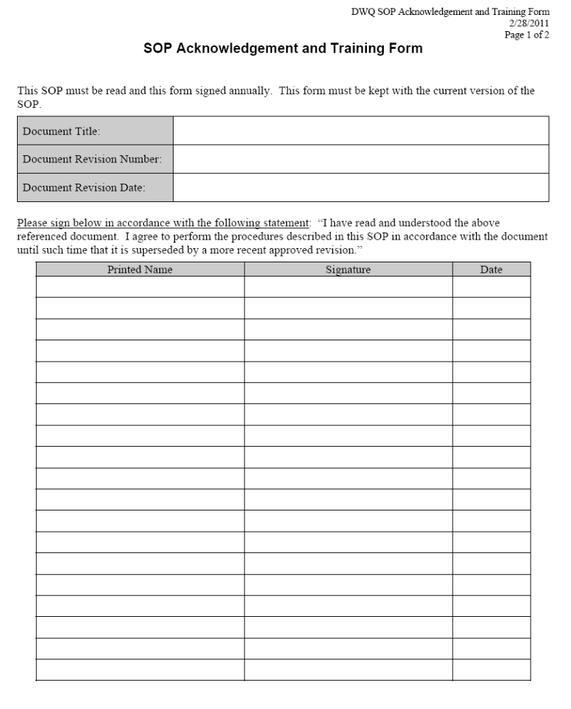

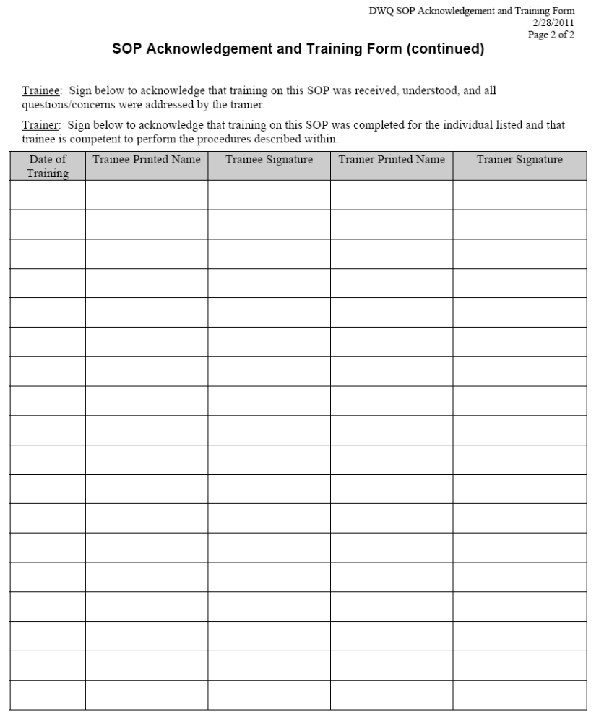

Appendix B – Portable Sampler field form
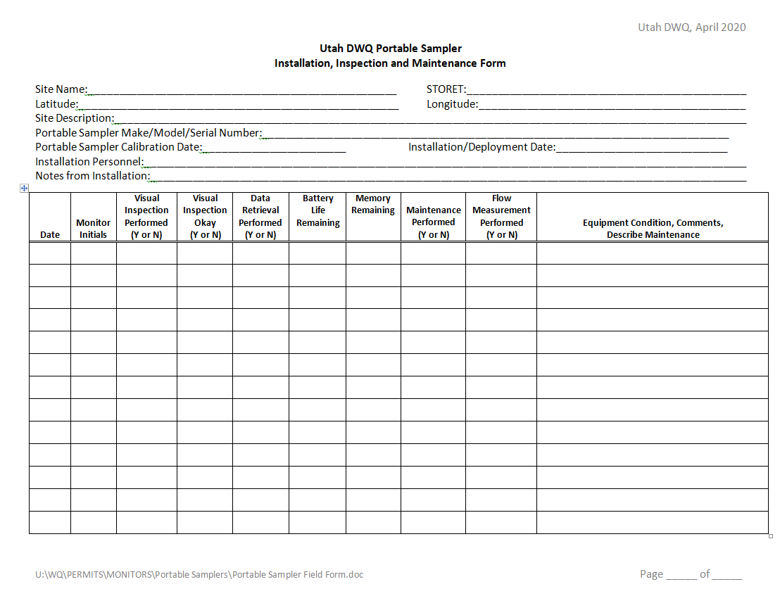

Disclaimer language above adapted from Washington State Department of Ecology SOPs.

